**Optimization setup for available resistors**

Setup the available resistors for Wilkinson power divider for BEST CT boards

CH0402 (F and P terminations) Performance is very good for 50-100 Ohm resistances. These are available at 50, 100, 150, 180, 200, 250, 330 and 500 Ohm.

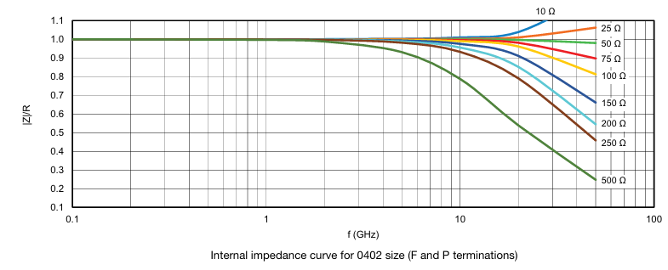

1.Calculate the impedance and resistor for Wilkinson power divider

Board 1:

f = [2 5] GHz, f0 = 3.5; Bw = 2.8 GHz;

W1 = 30.36 mils, Z1 =61.65 ohms; R1 =200 Ohm, /4=520.9mils;

W2 = 17.18 mils, Z2 =81.10 ohms; R2 =100 Ohm, /4=532.8 mils;

W0 = 43. 80mils, Z0=50 ohms

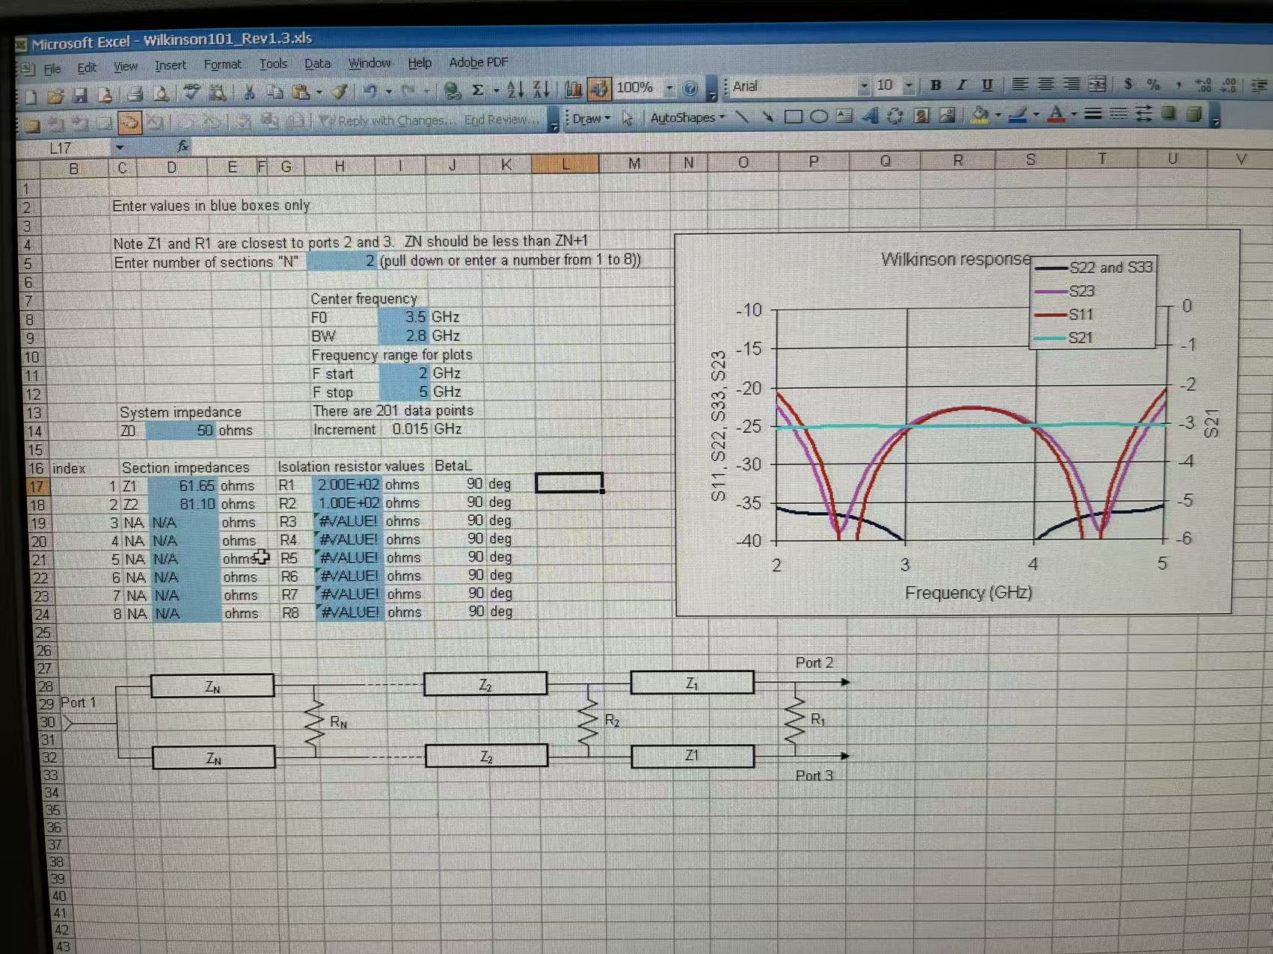

Board 2:

f = [5 6.7] GHz, f0 = 5.85; Bw = 1.7 GHz;

W1 = 32.18 mils; Z1 =59.73 ohms; R1 =200 Ohm; /4=310.3mils;

W2 = 15.945 mils; Z2 =83.71 ohms; R2 =100 Ohm; /4=319.2mils;

W0 = 43. 8 mils; Z0 =50 ohms;

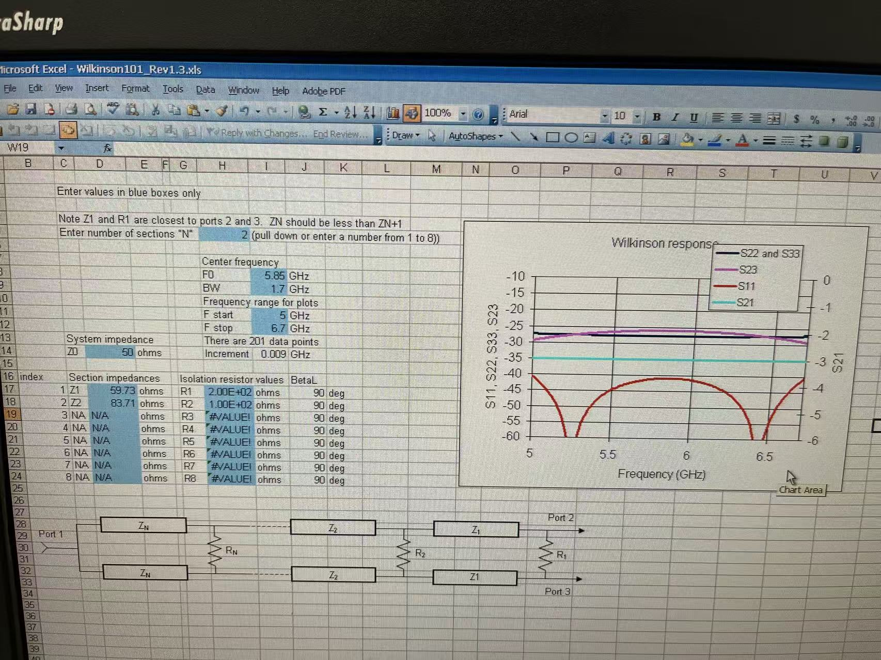

Board 3:

f = [7.3 9.0] GHz, f0 = 8.15; Bw = 1.7 GHz;

W1 = 32.36 mils; Z1 =59.60 ohms; R1 =200 Ohm; /4=222.24mils;

W2 = 15.89 mils; Z2 =83.89 ohms; R2 =100 Ohm; /4=228.8mils;

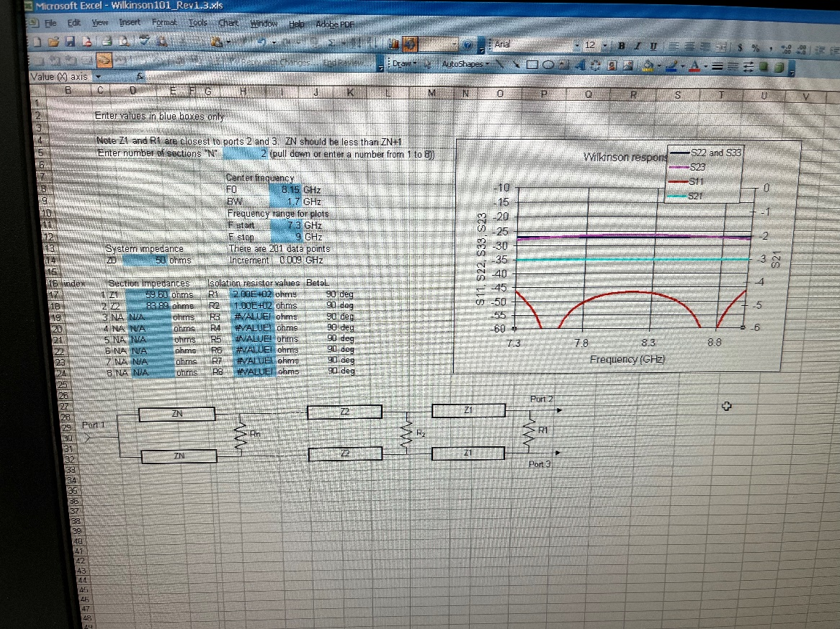

Board 4:

f = [9 12] GHz, f0 = 10.5; Bw = 3 GHz;

W1 = 32.31 mils; Z1 =59.72 ohms; R1 =200 Ohm; /4=172.126mils;

W2 = 16.01mils; Z2 =83.72 ohms; R2 =100 Ohm; /4=177.2mils;

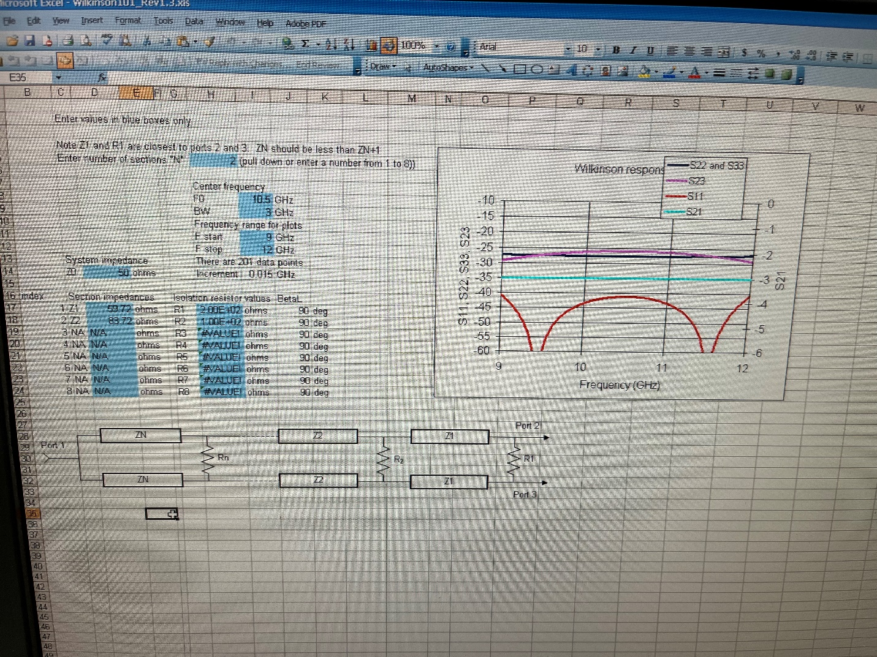

2. Calculate the effective impedance of the microwave strip by APPCAD software for RO4350

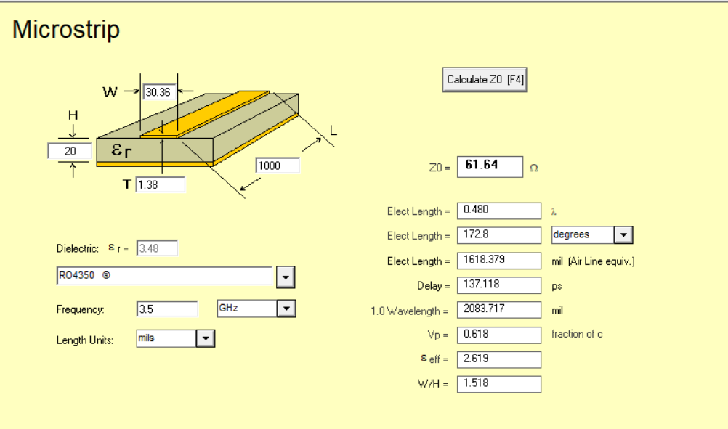

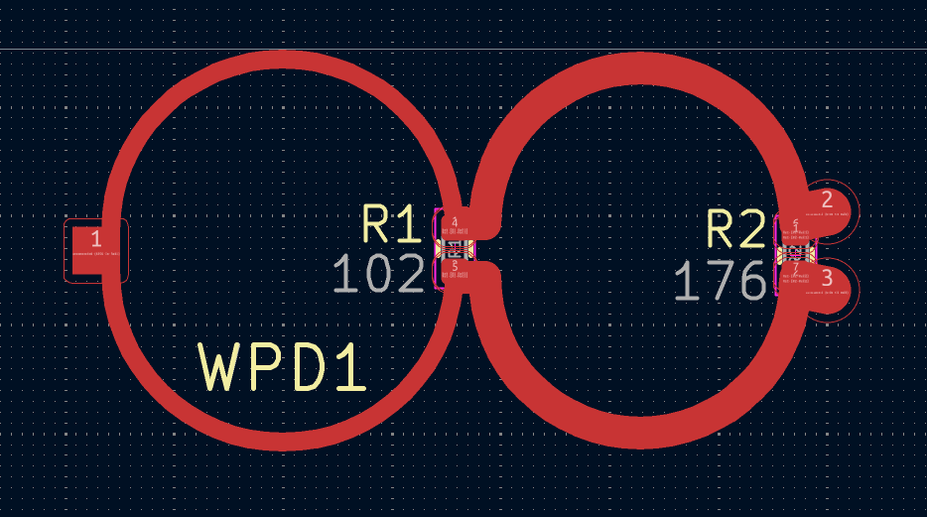

Simulation:

How to connect the

